|  |
| --- |
|  |

|  |
| --- |
| Accenture |
| **Business Advisors Power BI Dashboard** |
| Job Aid |

Table of Contents

1.0 Obtain necessary Power Bi (PRO) license for maintenance 1

2.0 Base/Input files Imported to Power bi Dashboard 2

3.0 Browse the BA Dashboard Landing Page 4

3.1 Summary Page 4

3.2 BA Headcount - HC Details 4

3.3 BA Project Details 5

3.4 BA Expert Details 6

3.5 Client Business Value (CBV) Details 6

3.5 Industry Learning 7

3.6 Adoptions Score 7

3.7 Gamification 8

4.0 Important Links related to BA Program 8

# Obtain necessary Power Bi (PRO) license for maintenance

Business Advisors Power Bi dashboard has been created to update the BA metrics month on month to BA PoCs of various functions at different location. This is published every month and the subscriber would need a valid license to view the dashboard. Hence they should have the same

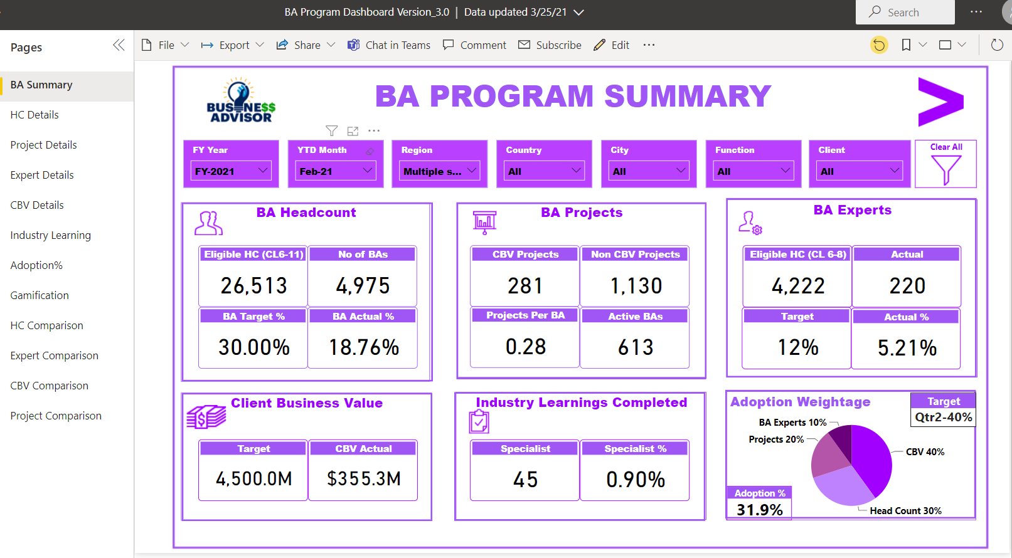

User requires Accenture username and password and necessary PowerBi Pro license to access the BA Dashboard.

User needs to click on the link which he receives in his Accenture inbox after publishing the Power Bi Dashboard .

After your login, the above summary page will be displayed.

# Base/Input files Imported to Power bi Dashboard

Data from below files is used to create the monthly BA Dashboard.

1. **BA Annual file** – for Quarterly data comparison between previous and current Fiscal.
2. **BA dashboard file** – Fundamental, Industry and Domain training completion status for BAs

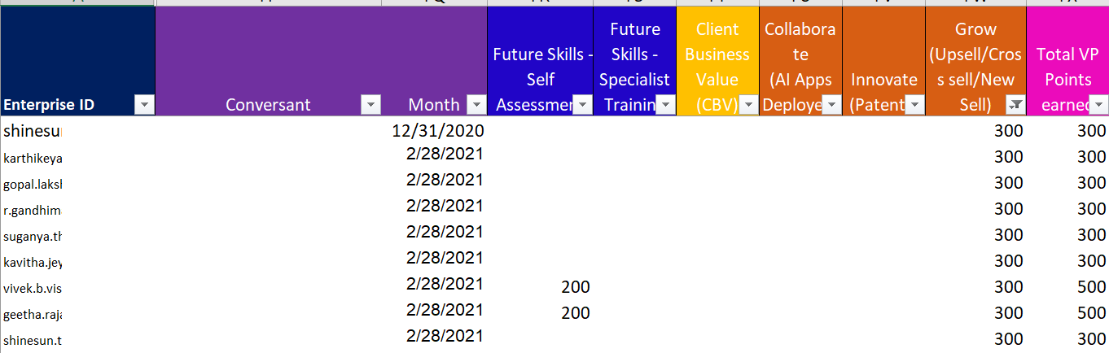

1. **Global Roster** – For month on month BA and BA Expert penetration status.

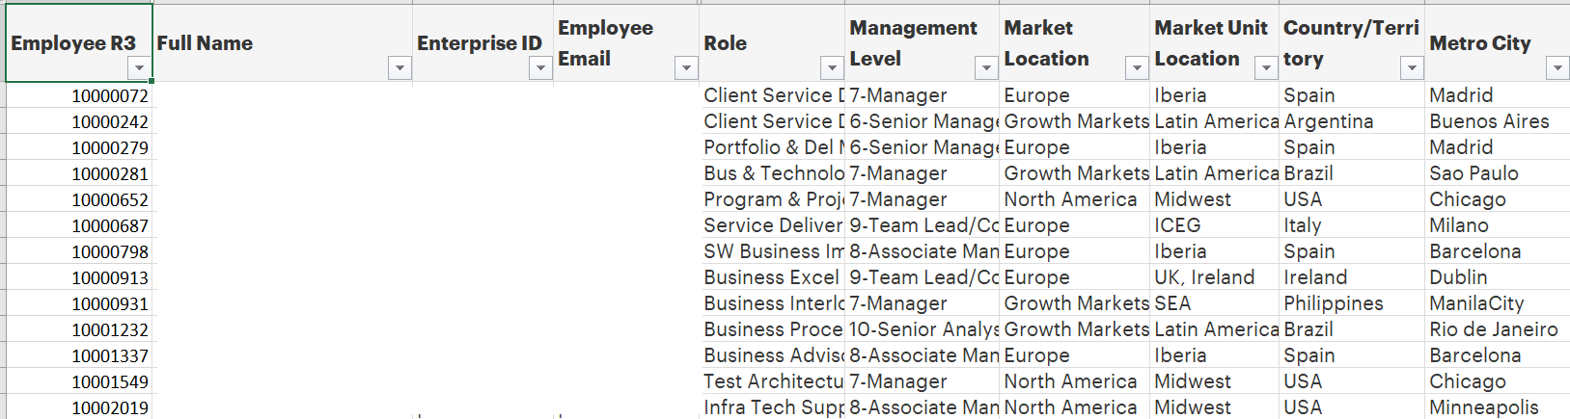

1. **Global targets** – Regions, City, Account wise deal targets.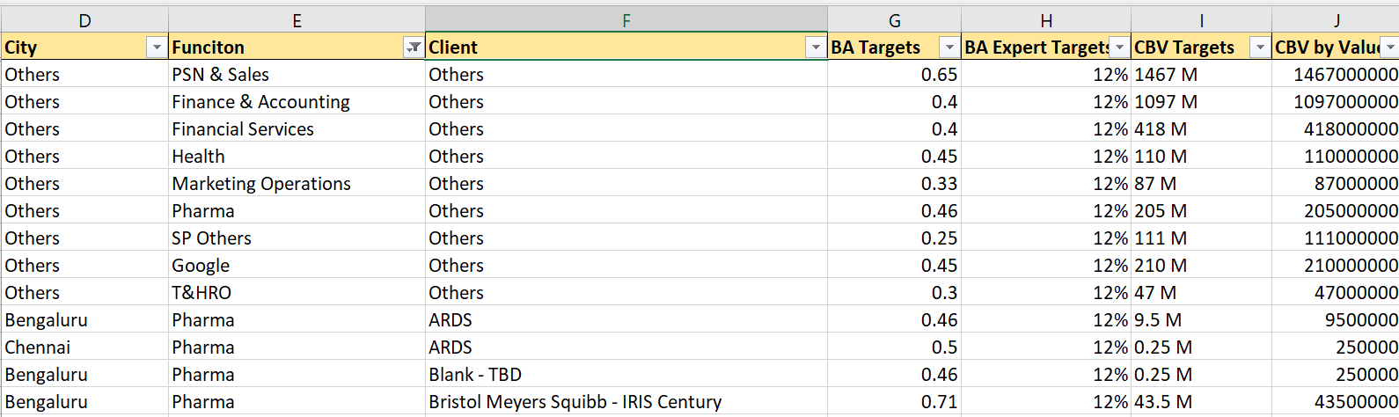
2. **Intelligent Ops status File** – for Insights Driven and Intelligent Account’s performance

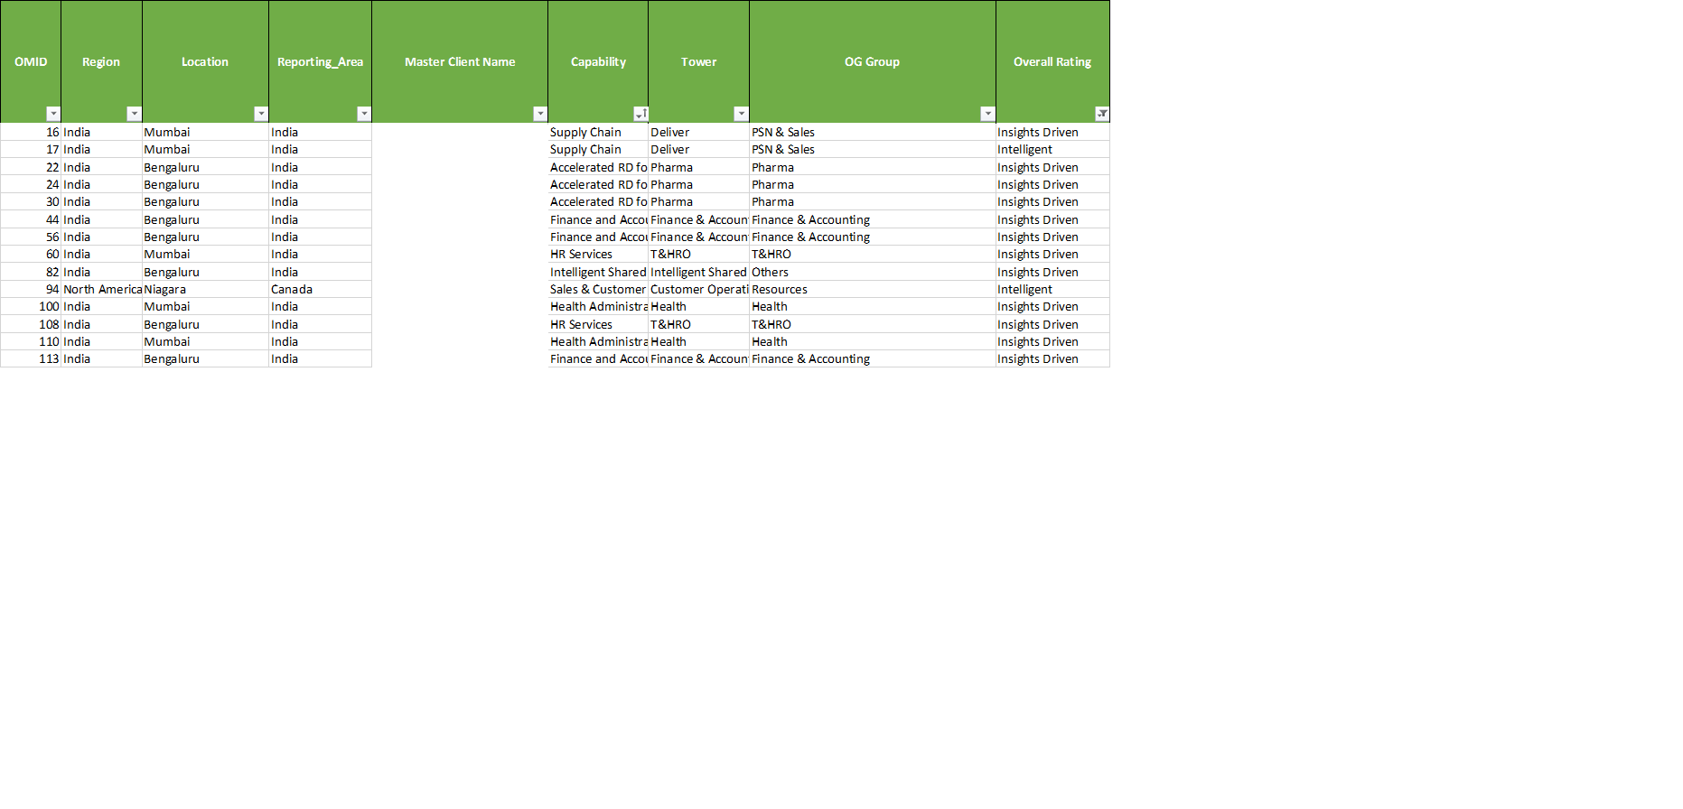

1. **CVM, DE&I and WeInnovate Extract** – Project counts and CBV numbers delivered by BAs

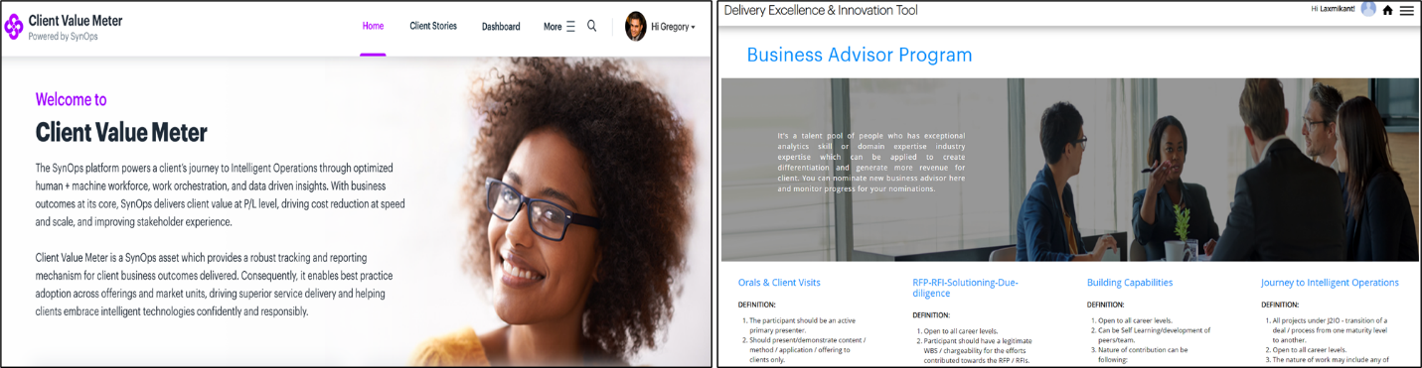

# 3.0 Browse the BA Dashboard Landing Page

## 3.1 Summary Page

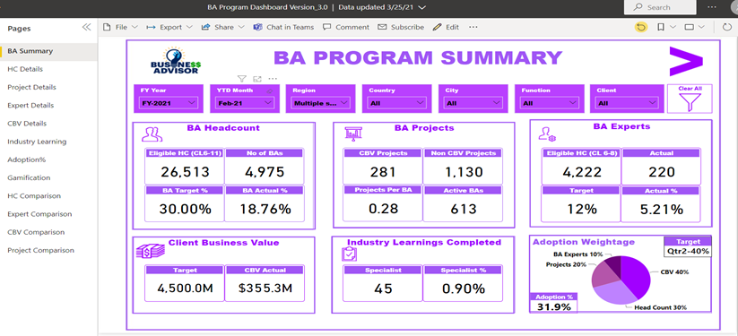

When the user login to the Power Bi by clicking on the link, above summary page opens up.

The page provides overall summary of all the current BA Metrics along with the current numbers versus the targets and performance wise adoption score. There are six filters on the top viz **FY Year, YTD Month, Region, Function** and **Client**. The user can drill down through each filter to check the status for Region or Function for each metric for particular month or Fiscal year.

## 3.2 BA Headcount - HC Details

This slide displays the Region, Country, City, Function and Account wise eligible headcount (CL6 to 11), BA headcount, current penetration and target penetration

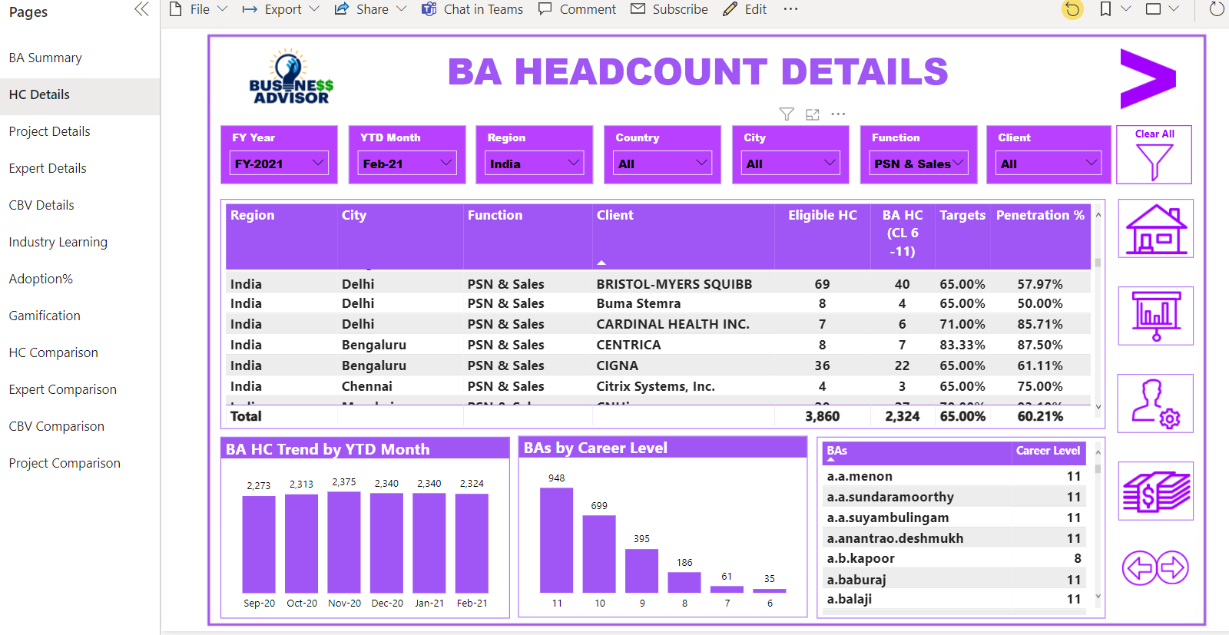

As shown in the figure above, the user can select any country, City or Function for a particular deal to know the current BA Penetration against the target as shown in the center table.

At the bottom there are 2 graphs and a table with BA names. The first Graph shows the month on month trend for BA in a particular Region/City/function and Account. While the 2nd graph represents career level wise break for BAs. Users may select a particular account in a selected city and accordingly the graphs are updated as per the numbers for that account. User may download the data in excel by clicking on the 3 dots on the top right hand side of that box and select export option.

**Expected actions required from BA PoC**

*This comparison of current BA penetration against target will help user to identify the gaps in meeting the BA headcount target for each Account and share the nominations whenever required*.

Towards the right hand side there are icons to navigate through different slides in the Dashboard.

## 3.3 BA Project Details

The next slide shows the Region, Country, City, Function and Account wise projects submitted by the BAs. 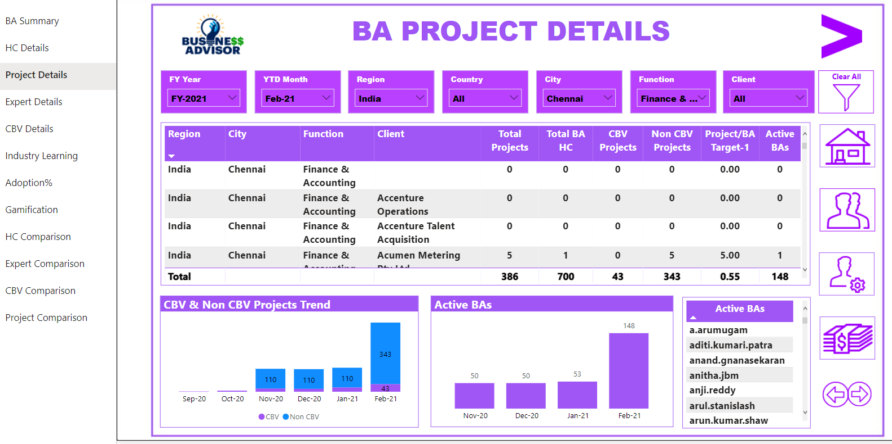

The project numbers are derived from consolidated projects submitted by BAs on CVM, DE&I tool and WeInnovate site. Drilling down through above filters, user can select any country, City or Function for a particular Account wise Projects submitted by BAs

The 2 graphs indicates CBV and Non CBV projects and Month on month trend of projects submitted. The extreme right table at the bottom indicates the unique count of BAs (along with their names) who have submitted the projects.

**Expected actions required from BA PoC**

*User to identify the non active BAs from their span push them to submit the projects for meeting the target numbers*.

## 3.4 BA Expert Details

In this slide User can check the BA Experts for various the Region, Country, City, Function and Account wise eligible headcount (CL6 to 8), 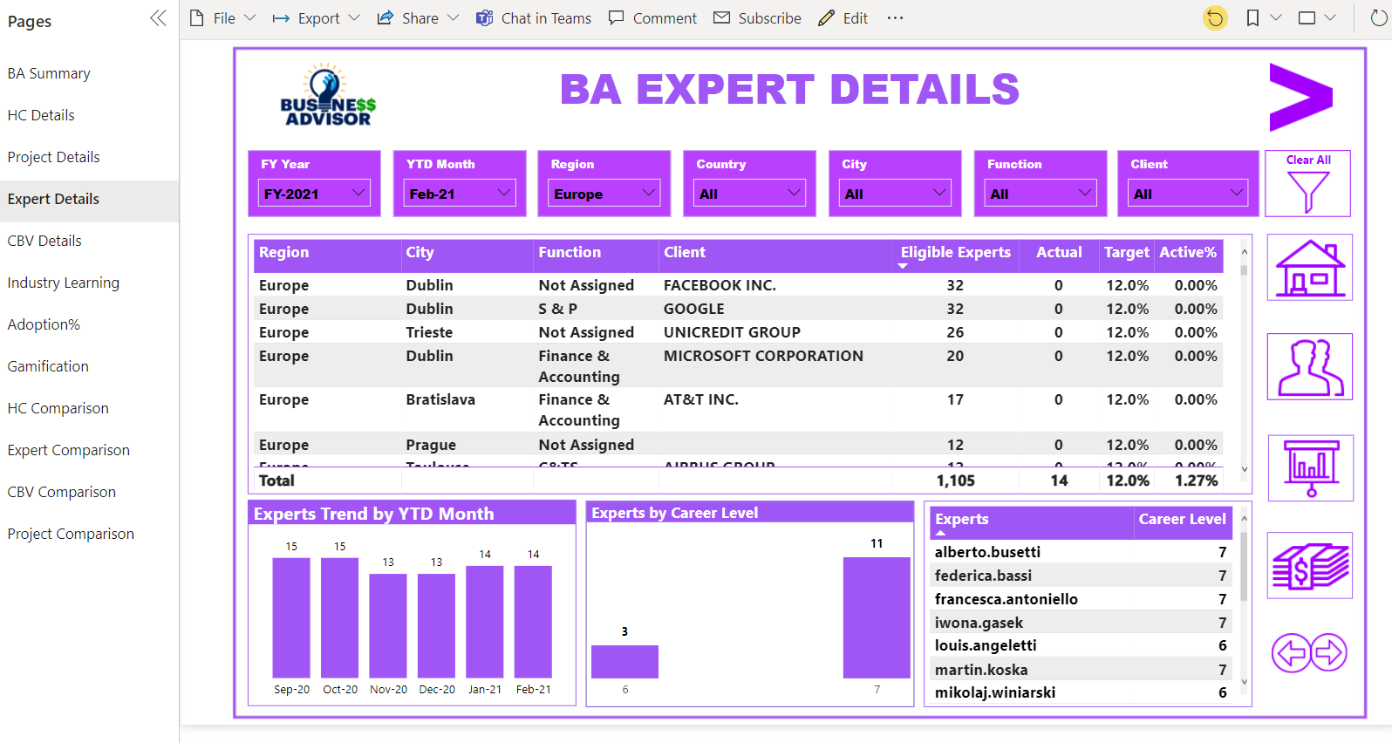

They can extract the current list of Experts clicking the 3 dots on the right-hand side of the box and then using the export functionality

**Expected actions required from BA PoC**

*User can identify the current BA experts for their span and share the nominations to fill the gaps to meet the target.*

## 3.5 Client Business Value (CBV) Details

This slide provide the Client Value delivered by BAs for different clients in USD.

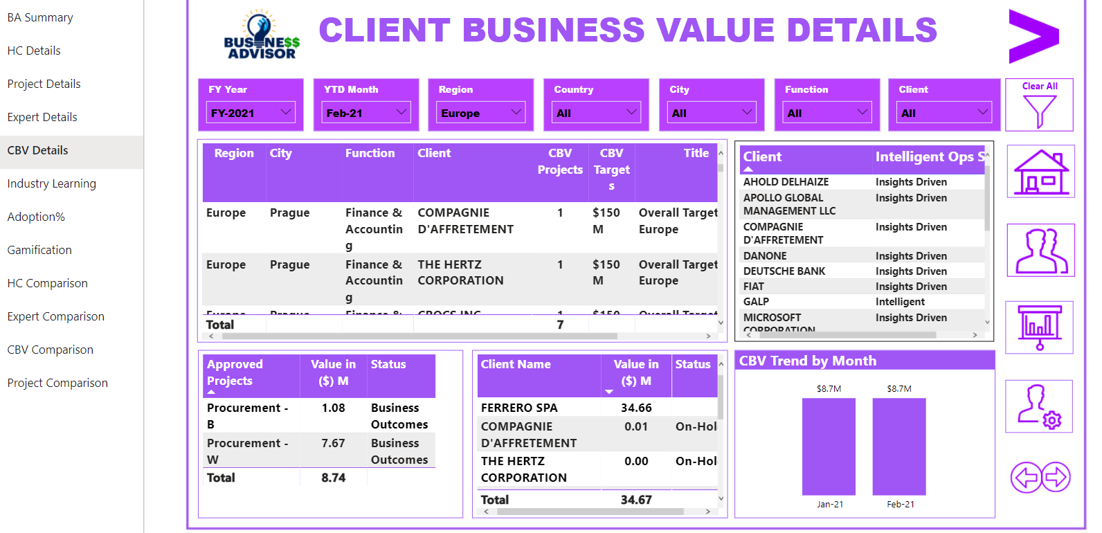

The slide indicates the approved Client Business Value (CBV) project numbers and CBV projects in pipeline. This will help the user to know the current status of CBV against the targets for their Span

Bottom Tables shows the CBV approved and Pipeline projects - account wise submitted in CVM tool.

**Expected actions required from BA PoC**

*Toward right there is table indicating accounts under Intelligent Ops status which are Insights Driven and Intelligent. This table help user to identify these accounts and connect with the respective SDLs to drive them to submit CBV projects in CVM Tool*

## 3.5 Industry Learning

This page gives the details of those who have completed Practitioner and Specialist trainings the at least one Industry BAs

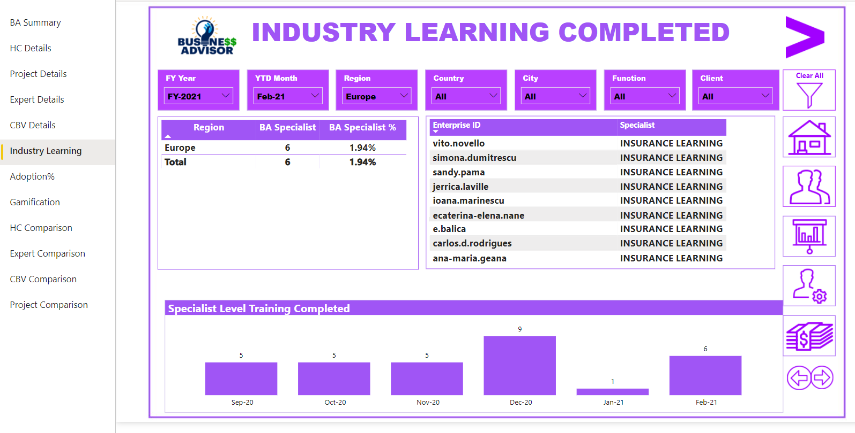

Left side table indicates the number of BAs completed at least one Industry Training. While the table on the right indicates the names of the BA with the Industry training completed.

The user can identify which BAs has completed trainings under Practitioner and Specialist level for a particular industry

**Expected actions required from BA PoC**

*User need to ask BAs to complete all the* *trainings under Practitioner and Specialist level for atleast one Industry*

## 3.6 Adoption Score

Adoption score is combination of Headcount (30% weightage on Adoption score), BA Expert (10% weightage on Adoption score), Projects (20% weightage on Adoption score) and CBV (40% weightage on Adoption score). Every quarter the adoption score should increase by 20%

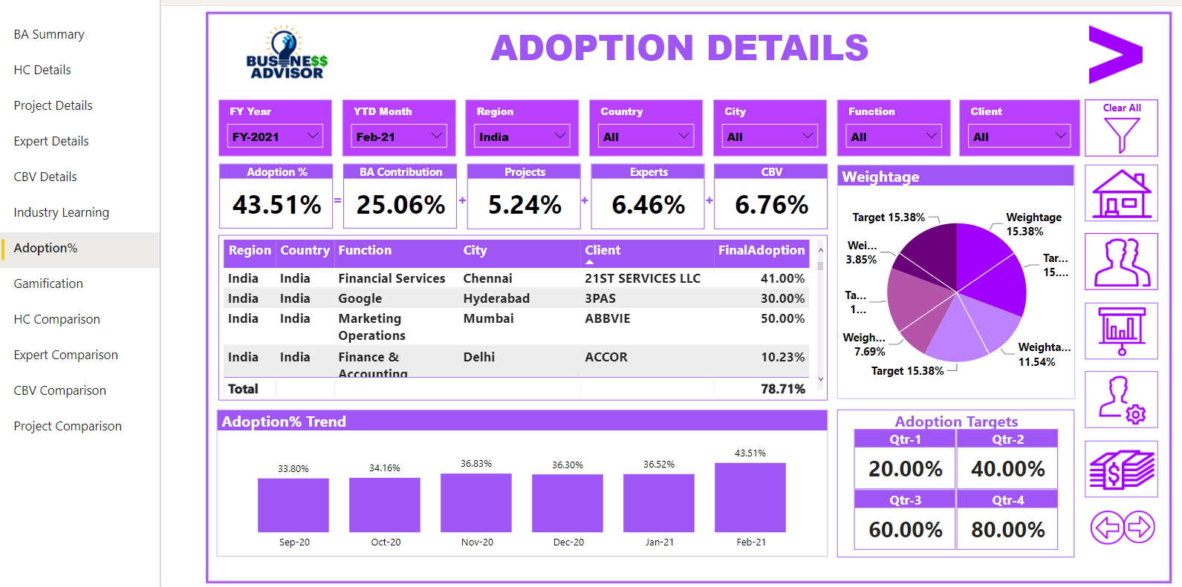

The user can check the current adoption scores for the respective Accounts or Span.

**Expected actions required from BA PoC**

*This slide enables the user to focus on those metrics where they are behind and drive the same amongst their Account/Span*

## 3.7 Gamification

This page indicates the virtual points earned by the BAs in different Gamification modules such as CBV, Future Skills and Leadership DNA.

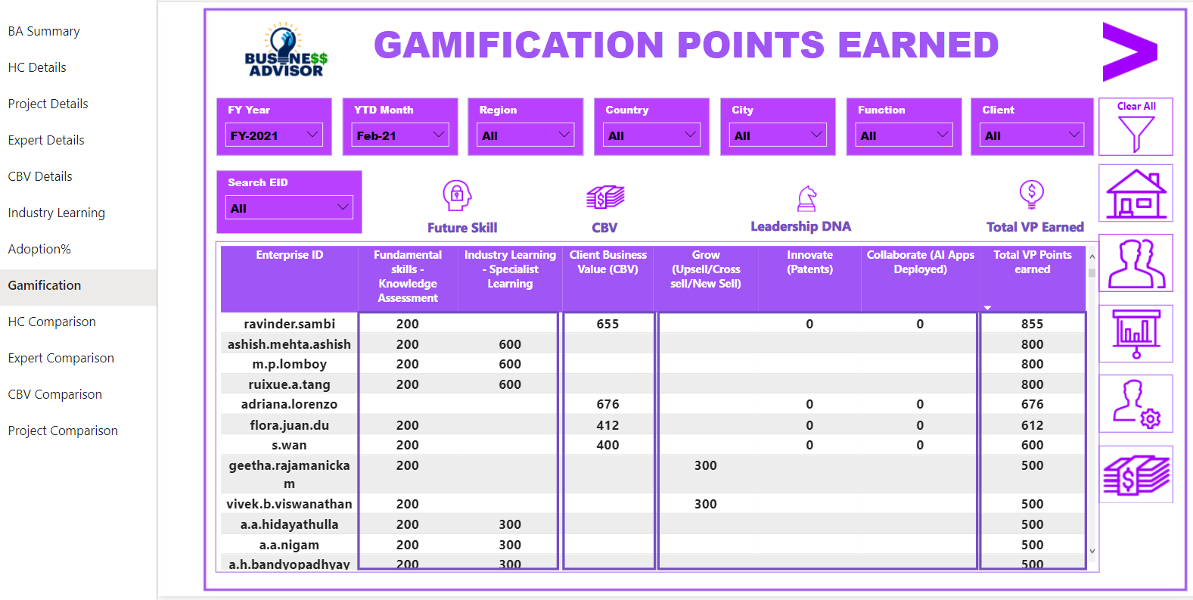

**Expected actions required from BA PoC**

*User can check the status for the respective BAs and cascade the same BAs in their span. This will help BAs to earn more and more Virtual Points which in future could be converted to Appreciation Points*

# Important Links related to BA Program

BA SITE : One Stop for all BA related information

<https://in.accenture.com/accentureoperationsdelivery/>

BUSINESS ADVISOR EXPLORER : Searching for Business Advisors with a specific Skill?

Login to the Business Advisor Explore A repository of all BA with their skills information

<https://specializedtalent.accenture.com/Pages/Home.aspx>

BA COLLECTIONS : A collection of the BA Learning Series conducted in FY21

<https://collections.accenture.com/collection.aspx?b=55c0e4d6> d019 eb11 b11f 0a0b3d281f9d

BA PROGRAM OVERVIEW (RECORDING) : Get an overview of the basics of the BA Program

<https://mediaexchange.accenture.com/media/1_i4mla962>

Client Value Meter tool (for CBV Projects)

<https://clientvaluemeteroperations.accenture.com>

DEI tool for Non CBV projects

<https://dei.accenture.com>